Curriculum Vitae   | 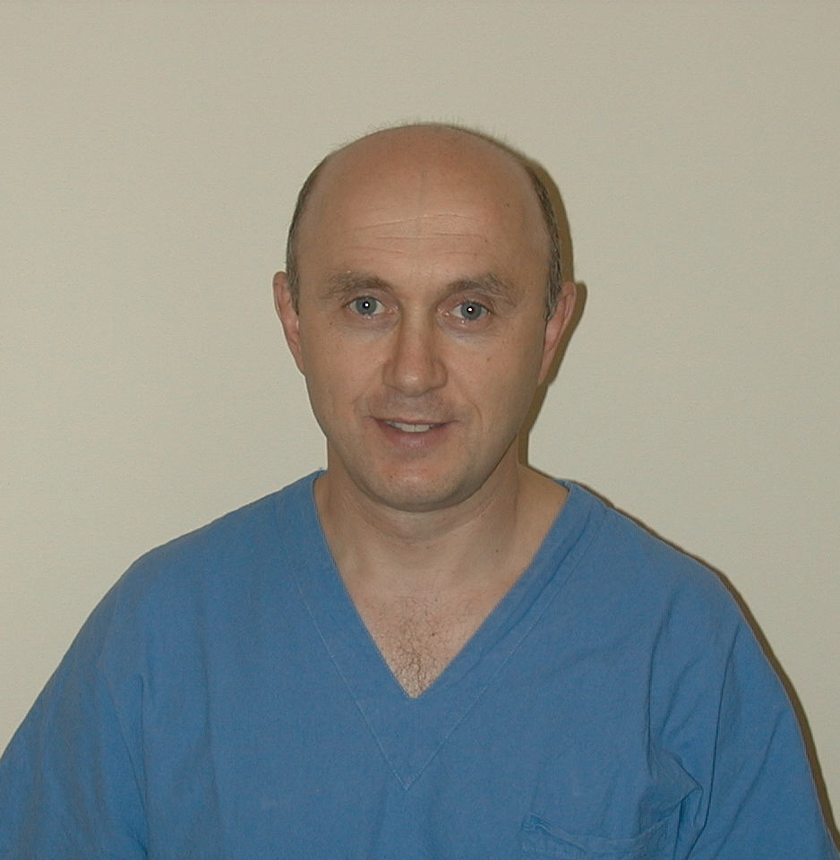
Personal informations
Name | prof Araldo Causero
Address | Via Roma, 69 33040 , Moimacco (UD)
Telephon number | 0432-559464
Fax | 0432.559298
E-mail | causero.araldo@sanita.fvg.it
Nationality | Italian
Date of birth | December 06 1955 C F: CSRRLD55T06F275C
Working experience | Currently directs the Orthopaedic Clinic in the University Teaching Hospital in Udine which consists of: 12 beds with 800 average inpatiens per year; ambulatorial activity with about 5000 outpatients per year; surgical activity with average 6 operation sessions per week and an average of about 800 surgeries per year including those on outpatients.
from 14 November 2006 | Chief of the Residency Program in Orthopaedics and Traumatology of the Universitary Hospital of Udine.
from 01 November 2006 | Director of the Complex Operative Unit of Orthopaedics of the directly managed Universitary General Hospital of Udine.
from 17 May 2006 | Full Professor of Clinical Orthopaedics of Udine.
from 1 March 2002 | Associate Professor of Orthopaedic Clinic, Udine.
from 01 January 1994 to 28 February 2002 | Tenured Physician of Orthopaedic Clinic of Udine.
from 24 August 1984 to 14 November 1993 | Senior Assistant in the Orthopaedic Clinic of the University of Trieste
from 15 November 1993 to 31 December1993 | Assistant in the Orthopaedic Clinic of the University of Trieste
from 01 December 1981 to 31 May 1982 | Practical Internship as Assistant of Orthopaedics and Traumatology
from 01 July 1981 to 30 November 1981 | Scholarship in the Orthopaedic Clinic of the University of Trieste
from 01 June 1982 to 14 January 1983 | Scholarship in the Orthopaedic Clinic of the University of Trieste
Instrucrion and Education | Attended many courses about specific topics of Orthopaedics and traumatology, as well as in other divisions and Orthopaedic clinics in Italy and other countries, to enhance and improve his knowledge in various branches of Orthopaedics and Traumatology.
2009 | A.S.Z. Hospital, Aalst, Belgium
2008 | University Medical Centre, Maastricht, Netherlands
2007 | Rothman Institute, Philadelfia, USA
2007 | Center for Reconstructive Surgery, Athens (GA), USA
2003 | Bone & Joint Center, St-Louis, USA
2003 | Hospital for Special Surgery, New York, USA
2002 | Keble College, Oxford, Great Britain
2001 | Hospital Clinic, Barcelona, Spain
1999 | Master in Economy and Management of Hospital Corporations
1998 | Specialist degree in Sport Medicine
1998 | S. Lukes Medical Center, Phoenix-Arizona, USA
1998 | Advanced course "Master in hip arthroplasty" in Orthopaedic Clinic in Milan, S. Paolo Hospital
1997 | Centre of Hip and Knee surgery, Mooresville-Indiana, USA
1997 | Advanced orthopaedic Center, Richmond-Virginia, USA
1994 | Clinique du Parc of Lyon
1992 | Course on the use of Gamma nail in pertrochanteric fractures in Reggio Emilia
1991 | Course of foot surgery, Alba
1990 | Orthopaedic Clinic, University of Florence
1990 | Orthopaedic Clinic, University of Rome
1989 | Orthopaedic Clinic, Southampton Great Britain
1987 | Orthopaedic division, Hospital of Vicenza
1986 | Course of hand surgery, Savona
1986 | Specialist Degree in Orthopaedics and Traumatology
25 June 1981 | Registered to the board of Physicians and Surgeons , Udine
06 March 1981 | Degree in Medicine and Surgery, University of Trieste
Teaching Activity | During academic year 2008/2009 Professor of Physiopathology of the Muscoloskeletal System for students of the course for degree in Medicine and Surgery.  Tutor for practical training of students of Medicine and Surgery. Supervisor for many theses. Supervisor for large numbers of specialization’s theses in Orthopaedics and Traumatology.  Member of the examining commission for degree courses in Medicine and Surgery, Specialization School in Orthopaedics and Traumatology, degree course in Sport Sciences, degree course in Physiotherapy.  Professor and Head of one of the courses of the Italian Society of Orthopaedics and Traumatology, which annual meeting in Udine is about the improvement of italian orthopedists in the field of knee ligament surgery.
 | Teaching of PATHOLOGY of the MUSCOLOSKELETAL SYSTEM for degree course in Medicine and Surgery
 | Teaching of TRAUMATOLOGY for degree course in Physiotherapy, University of Udine
 | Teaching of PATHOLOGY of the MUSCOLOSKELETAL SYSTEM for degree course in Sport Sciences, University of Udine
 | Teaching of PATHOLOGY of the MUSCOLOSKELETAL SYSTEM for degree course in Physical Education
 | Teaching of SURGICAL TECHNIQUES for the Specialization School in Orthopaedics and Traumatology, University of Udine
 | Teaching of BIOMECHANICS OF THE MUSCOLOSKELETAL SYSTEM for the Specialization School in Orthopaedics and Traumatology, University of Udine
 | Teaching of MEDICAL-SURGICAL EMERGENCIES for the Specialization School in Orthopaedics and Traumatology, University of Udine
 | Teaching of TRAUMATOLOGY for the Specialization School in Orthopaedics and Traumatology, University of Udine
 | Teaching of Orthopaedics AND TRAUMATOLOGY for the Specialization School in Sport Medicine, University of Udine
 | Teaching of Orthopaedics for the Specialization School in Pediatrics, University of Udine
 | Teaching of ORTOPEDICS for the Specialization School in Rheumatology, University of Udine
Teaching of PATHOLOGY of the MUSCOLOSKELETAL SYSTEM for the Specialization School in Geriatrics, University of Udine
Teaching of PATHOLOGY of the MUSCOLOSKELETAL SYSTEM for the Specialization School in Internal Medicine, University of Udine
Scientific Activity | Supervisor of several research projects. Published over 140 reports on Italian and foreign scientific magazines. Participated as lecturer or moderator in over 350 national and international seminars. Organized over 50 conferences.
Research Activity | Clinical Studies on staminal cells  -in the treatment of femoral head osteonecrosis  -in the treatment of articular chondral lesions  Studies in the clinical use of growth factors (PRP)  -in the treatment of septic and aseptic pseudoarthrosis  -in the treatment of rotator cuff tears  -in the treatment of meniscal tears  -in the reconstruction of acute and cronic anterior cruciate ligament lesions  Studies on the evaluation of osteointegration of articular prosthesis components (especially knee and hip)
Studies on the clinical evaluation of biomaterials, especially Tribology of new combinations in the field of arthroplasty
Clinical Studies on Tromboembolism in Orthopaedic and Traumatological Diseases
 | - evaluation of the effectiveness of pentasaccharides in major Orthopaedical surgery
- evaluation of the effectiveness of pentasaccharides in minor Traumatology
Clinical studies on the effectiveness of computer-assisted navigation in knee prosthetic surgery
Clinical studies on the evaluation of the effectiveness of bone and soft tissues allostransplants
-in prosthetic surgery of revision of failed septic and aseptic prosthetic implants
-in knee ligaments surgery
Studies on the functional evaluation through gait analysis and EMG in various Orthopaedical diseases
- knee pain syndrome
-outcomes of reconstruction with various surgery techniques of anterior cruciate ligament
Studies in progress | Longitudinal study with densitometric evaluation of the potential osteointegration of  Trabecular Titanium.  Multicentric National study, prospective, randomized, sponsored.
Fondacast study evaluation of the effectiveness and safety of Fondaparinux in the prevention of Tromboembolic events in immobilized patients..
Stage 3 multicentric study, randomized and supervised in open, sponsored.
LyDiss study: surveillance study of Lyme disease in FVG (Friuli Venezia Giulia).
Observational cohort prospectic study, multicentric, spontaneous.
DIRECT study.
Open-label study, randomized, controlled, sponsored for evaluating the safeness and pharmacokinetics of Diclofenac subcutaneous administrated in patients who underwent minor Orthopaedical surgery.
Study on the evaluation of kinetic and kinematic based on gait analysis and EMG sulla valutazione cinetica e cinematica basata su gait analysis ed EMG in
patients with knee pain syndrome.
Prospective, randomized, spontaneous study.
Study on the evaluation of kinetic and kinematic based on gait analysis and EMG in
patients who underwent reconstruction of anterior cruciate ligament with various techniques.
Prospective, randomized, spontaneous study.
Study on the acquisition of morphological and kinematical data in computer-assisted knee prosthetic surgery.
Multicentric National study, prospective, randomized, sponsored.
Study on the acquisition of morphological data and on the evaluation of the effectiveness in computer-assisted knee prosthetic surgery.
Prospective, randomized, spontaneous study. Waiting for ethics commission opinion.
Personal Abilities and Proficiencies
Obtained during lifetime and career but not necessarily recognised by official certificate or degree.
Native language | Italian
Other languages
Reading ability | English
Writing ability | English
Oral expression ability | English
GCP Clinical Trials Experience  Additional Informations | Twenty years experience in Clinical Trials in field of cartilage repair, osteoarthritis, tendons injury, arthroplasty, ligaments reconstruction, medical devices.
Attachments
 | The undersigned knows that for the art. 26 of law 15/68, mendacious declarations, falseness in documents are punished according to the criminal law and special laws. Furthermore, the undersigned authorizes to the treatment of personal data, as provided by Law 196/03.
Udine, 24.02.2023 | Araldo Causero  ----------------------------------------

