EUROPEAN curriculum vitae

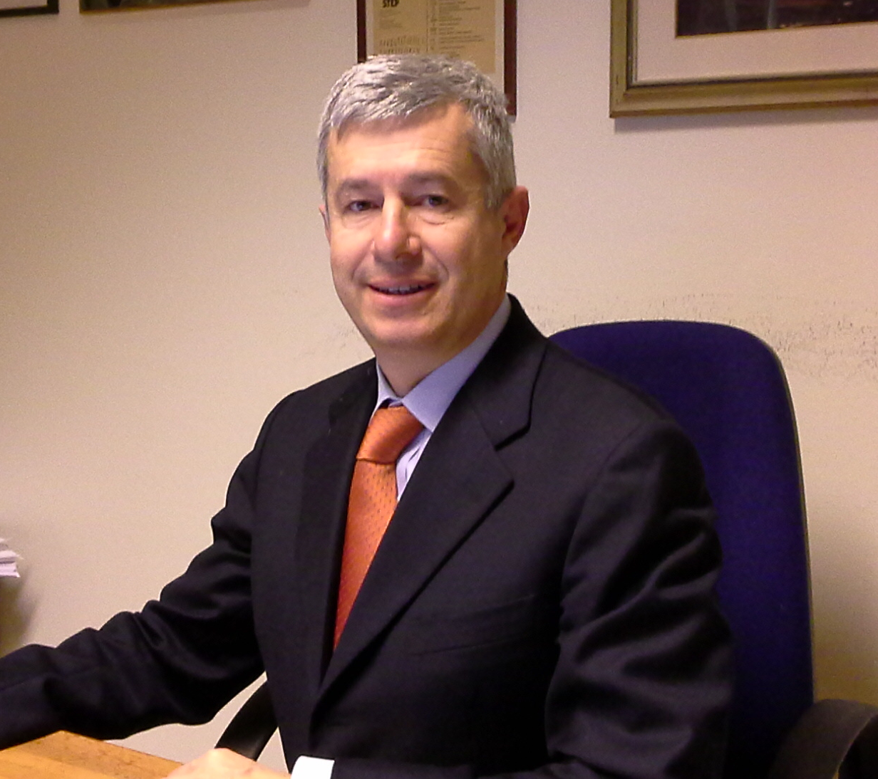

Name and surname  Date of birth |  | Carlo Moreschi  06.06.1959
Telephone number |  | 0432 554363
E-mail |  | carlo.moreschi@uniud.it
Pec |  | carlomoreschi@pec.it
Current assignment
Associate Professor of Legal Medicine
UNIUD – Department of Medicine, Section of Forensic Medicine

Working experience

7-11-1994 Researcher at Section of Forensic Medicine of University of Udine.
In 1997/98 – 1998/99 - 1999/00 – 2000/01 – 2001/02 – 2002/03 Representative of the Researchers at the board of Directors of University of Udine.
In 1997/98 – 1999/00 – 2003/06 member of the Researchers board at the Faculty Council.
Since October 2019 Associate Professor of Legal Medicine, Section of Forensic Medicine (DAME) of University of Udine.
Professor of Legal Medicine at Medical school, at Nursing school, at Phisiotherapy school and at Biomedical laboratory school.
Professor of Legal Medicine at Medical specialization schools of DAME.
Author of many scientific pubblications, also in international journals.
Since 1985 attendant in many national and international meetings.
Past member of Ethics commitee.
Director of SOSD of Legal Medicine of Health Responsability at ASUFC.

education add training

Scientific High school diploma.
In 30/10/1984 Degree in Medicine at University of L’Aquila, summa cum laude.
In 1987 Specialization in Legal Medicine and Social Insurance at University of Parma.

personal skills

native language |  | italian

other language

ENGLISH

. |  | Medium level

OTHER SKILLS  . |  | Expert consultant for many penal and civil Courts.  Expert consultant for insurance companies, involved in a medico legal head board insurance.

Udine, 22-9-2023

Carlo Moreschi


